Week 2 – Mechanical Design   
  
Author: Eric Vuong, Yu Chen Xu

Date: February 27th, 2015

Hardware: Version 1.0  
Goal: Explain the mechanical design choices of each part of the robot and how it will interact with the software department.

Contents

Mechanical Design Choice 2

Brick 2

Ultrasonic Sensor 2

Navigation 2

Obstacle Avoidance 2

Testing 2

Light Sensor 2

Cardboard 2

Motors 2

Navigation & Odometry 2

Launcher Mechanism 2

Loading 3

Glossary of Terms 3

Distribution 3

# Mechanical Design Choice

## Brick

The result of Lab 5 in Research & Development was the decisive factor of whether number the final design should use one or more NXT brick. With all three teams capable of launching the Ping-Pong ball with only one motor and one team being able to autonomously reload after every launch, the number of bricks used will be only one. Furthermore, this can make the code and the design much less complex.

## Ultrasonic Sensor

The number of ultrasonic sensors used will be 2: Front Ultrasonic Sensor (FrontUS) and left Side Ultrasonic (SideUS).

### Navigation

When the robot is in navigation mode, only the FrontUS will be enabled. The purpose of the FrontUS during Navigation Mode will be to perceive any incoming obstacles. Whenever an obstacle is too close, the robot will rotate to its right until the FrontUS doesn’t perceive an obstacle anymore. In other words, it has a consistent reading of over 100 (Value subject to change post-testing).

### Obstacle Avoidance

The FrontUS and SideUS will be used to prevent collision with its surrounding.

### Testing

Further tests will be conducted to further confirm the liability of the 2 ultrasonic sensors, such as creating different scenario to observe the 2 ultrasonic sensor’s ability to avoid obstacles at different orientation and size.

## Light Sensor

Due to the success of Lab 2 and 4 in Research & Development, the same method will be used to localize and detect gridlines (Refer to software development for more information). The light sensor will be placed in the back and calculations of the sensor’s offset from the robot’s centre of position will be taken into account in the coding process.

### Cardboard

In order to enhance the accuracy of the light sensor’s reading and allow it to be consistent despite the lighting of the environment, cardboards will be placed around the light sensor to prevent outside light from interfering with the data collection. In this way, the light value of the gridlines shouldn’t change if there are more or less light in the environment of the robot. Further tests will be conducted to confirm the efficiency of the light sensor.

## Motors

### Navigation & Odometry

The robot will utilize all three motor ports of the NXT brick. 2 Motors will be used for the left and right wheel of the robot (port ‘A’ and port ‘C’). Due to the success of the odometer and navigation lab in Research & Development, the motors responsible for the wheels will function similarly.

### Launcher Mechanism

The third motor (port ‘B’) will be used for the launcher. The launching mechanism uses two pieces of Lego tied together with an elastic band, which is then connected to the motor. The motor rotates the Lego, and another piece of Lego is placed in a way where the outer piece’s path is blocked, while the inner piece continues to rotate. Since the inner and the outer pieces are both attached to each other, the inner piece that continues to rotate will pull the outer piece until it does not reach the blocking Lego piece that acts as a way to pull back the Lego. Once the outer piece is released from the blocking piece, the elastic energy that is stored while it was blocked is transferred to the ball by batting the ball horizontally, thus launching the ball. Afterwards, the inner and outer pieces continue the rotation until it reaches the blocking piece again, and repeats.

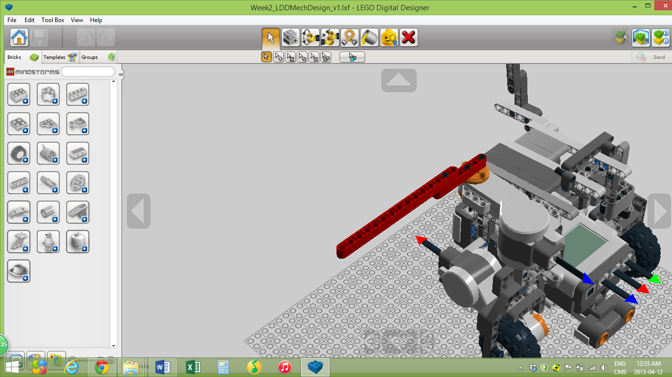

As seen, the 2 sticks in red are attached with an elastic band.

### Loading

The loading system will be using gravity as the force to pull the ball to the shooting spot. Upon the shooting spot, there will be a vertical long brown tube, which serves as the pool of the balls. As one ball gets hit, another one will come down to replace the previous one.

# Glossary of Terms

FrontUS – Front Ultrasonic Sensor  
SideUS – Side Ultrasonic Sensor

# Distribution

This belongs to the hardware department.